Artistic Directors: Mara Vinson & Oleg Gorboulev

THE NUTCRACKER Auditions
Olympic Ballet Theatre will be holding open auditions for its annual production of The Nutcracker. 2-4 years of ballet experience is required.

Date: Saturday, September 24th

Location: Olympic Ballet School Studios
700 Main Street Edmonds, WA
Studio C (Rm 122)

Times: 7-8yrs old: 1:00-1:45
9-11yrs old: 1:45-2:30
12-14yrs old: 2:30-3:15
$20 Audition fee payable to Olympic Ballet Theatre. Cash or check only. To register email dance@olympicballet.com
Performances: Dec 9-11 & 15-18 in Everett & Edmonds
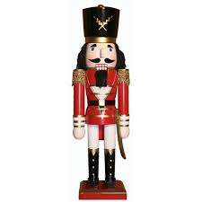

Olympic Ballet Theatre & School 700 Main Street Edmonds, WA 98020 425-774-7570
www.olympicballet.com facebook/olympicballettheatre

